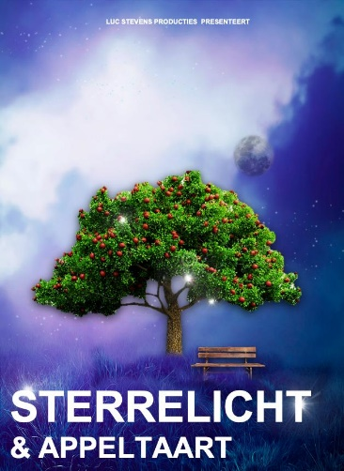
Entrance free
Theatre Play Starlight
Starlight is a story that moves. Hard and painfully topical about loneliness. Hopeful and cozy, about being connected and gathering in warm neighborhoods and open institutions.
Date:
Time:
Location:

